### TOROS University

#### Computer and Software Engineering Department

##### SCE-216 Web Programming 2

##### Lecturer: Asst. Prof. Dr. Maryam Eskandari

**Duration: 60 minutes**

**Name, Surname . . . . . . . . . . .** 

|  |
| --- |
| ***Q1. /*** |
| ***Q2. /*** |
| ***Q3. /*** |
| ***Q4. /*** |
| ***Q5. /*** |
| ***Q6. /*** |
|  |
| Total |

**Student ID # . . . . . . . . . .**

**Grading:**

Please, check your exam sheet and make sure that it contains **6 questions** .In case of **any missing pages**, **inform the invigilator** IMMEDIATELY !

**1) How can the index.php script access the email form element of the following HTML form?**

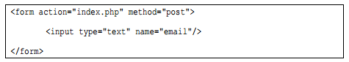

**2)** **What will be the output of the following script?**

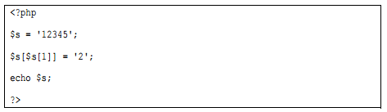

**3)** **This question refers to a table named president with schema as follows:**

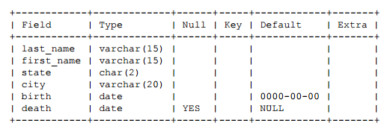

1. **Write an SQL query that returns the full names of presidents who are still alive.**

|  |
| --- |
|  |

1. **Write an SQL query that finds the state in which the greatest number of presidents have been born.**

|  |
| --- |
|  |

1. **Write an SQL query that finds the full name of every president between 60 and 70.**

|  |
| --- |
|  |

**4)** **Write a SQL statement to create a simple table employees including columns id, name and salary.**

|  |
| --- |
|  |

**5)** **Write complete PHP code to delete all students with grades less than 50 from table student of mydatabase using a textbox and button, show your deleted items into a textarea using method POST.**

|  |
| --- |
|  |

**6) Suppose we have the following 1D arrays, write a complete PHP code to find the sum of arrays.**



**Array a =**



**Array b=**

**sum=**

|  |
| --- |
|  |